The Metropolis Monte Carlo Simulation of Br Atoms on Cu Surface

(Research Report for UROP Project, Summer 2013)

Shen CHEN, N. Lin (Supervisor)

Department of Physics

HKUST

Hong Kong

schenad@stu.ust.hk

*The purpose of the project is to simulate the behavior of Br atoms on Cu surface using Metropolis Monte Carlo algorithm developed by Nicholas Metropolis et al. in 1953 [1]. In the experiment, when Br atoms were slowly cooled down on Cu surface to a quite low temperature (~5K), they formed some steady islands, whose characters were also affected by different coverage of the atoms on Cu surface. The “Br atoms” in the simulation also formed some similar islands. By considering the differences of size distribution, shape distribution and the pair correlation function of the simulation and experimental results, the relationship between the forces (bonding and repulsion) in this process could be finally decided.*

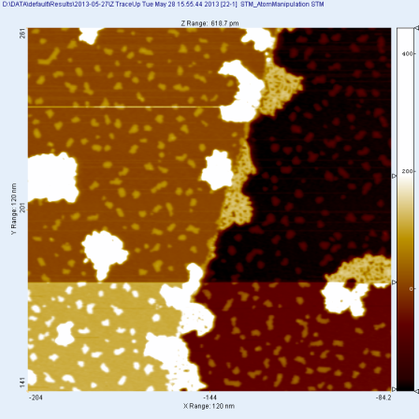Fig. 1. STM image of the Br islands on Cu surface. The large white speckles are molecules; the small ones are Br islands

Keywords—Metropolis Monte Carlo algorithm

# Introduction

In the experiment, the Br atoms were firstly distributed on the Cu surface at about 300K while the sample started to be cooled down. When the temperature closed to 50K, the moving of Br atoms began to be stopped and some localized islands were formed. As the temperature reached to 5K, the atoms seem to be “frozen” under the STM and the steady islands were formed (Fig. 1).

To study the reason for the phenomenon, Metropolis Monte Carlo algorithm was being used to simulate this system. In order to compare the simulation and the experiment, the distribution of size, the distribution of shape and the pair correlation function of these islands have been used to characterize the Br islands:. By compare these three characters of the Br islands in experimental results and the simulation results, the correctness of the model used in the simulation could be verified so that the model can be finally used to explain the experimental results.

# modeling of the simulation

Triangular grid graph is used in this simulation as the “lattice”. It is defined that “Br atoms” can only move among the lattice points. In each step, one randomly chosen atom will be moved and ∆E, which is the difference between the system energy before and after moving, will be calculated. Whether accept this step will depend on the result of ∆𝐸, which is defined by the equation (1):

$∆E=-E_{B}×{∆N}_{B}+∆(\sum{A×\frac{1}{r^{3}})}$ (1)

where $E_{B}$ is the bonding energy of one bond, $N_{B}$ is number of bonds formed around the chosen atom, A is the constant of repulsion and r is the distance between the chosen atom and any other atoms on the lattice. If ∆E ≤ 0, the possibility to accept the step should be 100%. If ∆E > 0, the possibility to accept the step should be the Boltzmann factor $e^{-\frac{∆E}{k_{B}T}}$.

## Simplification of the Model

Since the “frozen” of Br atoms were observed under a quite low temperature (~5K), if the sample could be cooled to a lower temperature, e. g. close to the absolute zero, the Br islands should be more stable as expected. Hence, to simplify the original model based on Metropolis Monte Carlo algorithm, first let T→0 (K) to see what will happen. As the result, the Boltzmann factor ${ e}^{-\frac{∆E}{k_{B}T}} → 0$, i. e. the possibility to accept the step is 0%. In other words, if ∆E ≤ 0, the moving will be accepted in this simplified model. Otherwise, the moving will be rejected. Since this simplified model has no relationship with the Boltzmann factor $e^{-\frac{∆E}{k_{B}T}}$, and only the signal of ∆𝐸 affects the acceptance of the moving of Br atoms, the unit of the variables in equation (1) can be ignored, which is a huge simplification. The only factor that affects the final result is the proportion $E_{B}:A$ if the coverage is determined.

## Calculation of the Coverage

As shown in Fig. 1, the STM image from the experiment also contains some molecules (large white speckles), which would not be studied in this project. To calculate the real coverage of Br atoms, separating the molecules and Br islands is needed. By using the toolbox in the *Photoshop* to process the STM images, one could get an image only containing some molecules and an image only containing Br islands from each STM image. With a Matlab program (“coverage.m”), the coverage of molecules and Br islands can be calculated separately for each picture. The formula to find the real coverage of Br atoms is:

$Corrected Coverage=\frac{1}{\frac{1}{Coverage of Br} - \frac{Coverage of Molecular}{Coverage of Br}}$ (2)

After processing three sets of experimental data, three different values of coverage were got, which are 10.92%, 33.65% and 71.95%, respectively.

## Simulation Results of the Simplified Model

By looking at the process of the evolution of the model, it could be found that the “Br islands” would be stable at about 106 steps. As for the size and shape of the lattice, first set it to be a diamond with 100 atoms on each side. As these parameters are fixed, the only variable is the proportion ${ E}_{B}:A$.

By setting ${ E}_{B}:A=1$ at the beginning, many small triangle islands consist of 3 atoms were observed. As the proportion gets larger, the islands become larger and larger, which can be seen in the size distribution of the “Br islands” in simulation results.

| $${ E}_{B}:A$$ | 1 | 1.5 | 2 | 2.5 | 3 | 4 | 5 | 106 | 1012 |
| --- | --- | --- | --- | --- | --- | --- | --- | --- | --- |
| Peak position of size distribution (atoms) | 3 | 4 | 5 | 7 | 7 | 7 | 7 | 7 | 7 |

1. size distribution of br islands

The second row of Table I represents the size of the islands that have the most population, and the unit of size is “atom”.

The result implies that the islands are “growing” larger when increasing the bond energy with ${ E}_{B}:A≤2$. Most of islands consist of 7 atoms when ${ E}_{B}:A≥2.5$, while the islands just stop growing larger when increasing the bond energy, even if the proportion goes to an enormous number. Comparing with the experimental result, which shows that the peak position of size distribution is at about 20 (Fig. 2), the difficulty of the original model appeared.

# Solutions for the inconsistence between the experiment and simulation

By applying the simplified model to different coverage, the same phenomenon still appeared: the 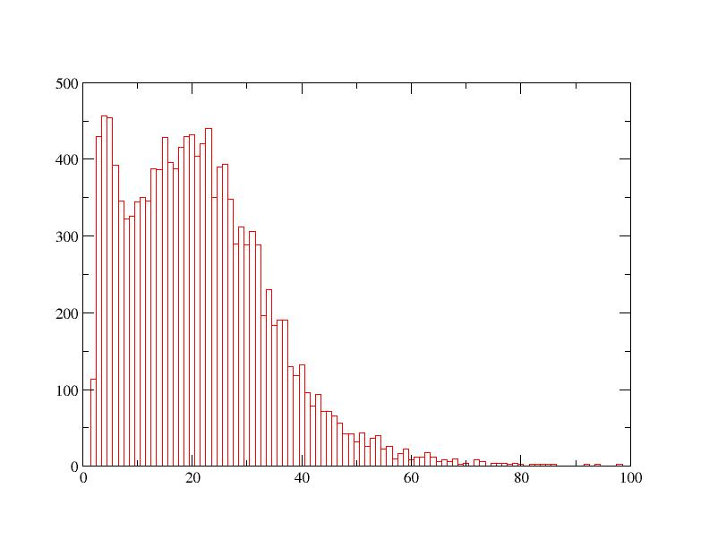islands just stop growing larger when increasing the bond energy if the proportion ${ E}_{B}:A≥5$, even if the proportion increased to a huge number. To solve the inconsistence between the experiment and the simplified model, some modifications to the simplified model have been done.

## Increase the Size of Lattice

It was considered that size of lattice may be a constraint to limit the size of the islands. However, the simulation results shows that, even the lattice expanded to a diamond with 200 atoms long of each side, the situation still remained unchanged, i. e. the peak position of size distribution still stays at 7, which means that increasing the size of lattice has little effect on the size of the islands.

## Cancellation of Periodic Boundary Condition

The “Br islands” cannot grow larger in the simulation as expected implies that the repulsion dominates the process and prevents more atoms from gathering together. As the calculation of distance is governed by the periodic boundary condition in this model, if it is cancelled, the distance that will be used for calculating the repulsion will be longer. As the result, the repulsion should be weaker in this modified model, and it was expected that the “Br islands” trend to grow larger since it is easier for the “atoms” to gather together.

Fig. 2. Size distribution of the experimental Br islands under the coverage equals to 10.92%. The x-axis is the size of Br islands, defined by the number of atoms contained in the islands, the y-axis is the number of island with certain size.

However, it was observed in the simulation that the cancellation of periodic boundary condition only caused the atoms moving towards the edge, but had little effects on the size distribution of the islands. No matter how large the bond energy is, the peak position of size distribution will still stay at 7 if the proportion ${ E}_{B}:A≥5$.

## Starting From Some Large Islands

The original model starts the Monte Carlo simulation from a diamond lattice with “Br atoms” randomly distributed on it. If the simulation starts from some big island, it was expected to cause some differences on the simulation results.

However, the simulation shows that with the proportion ${ E}_{B}:A≥4$, approximately, the large islands cannot be broken. With a proportion ${ E}_{B}:A<4$, the island can be broken, but size distribution of the islands is still similar to the original case, which has the peak position of size distribution at about 7. Some further study about this case shows that the broken of “Br islands” always start from the center, and the larger “Br islands” are, the easier it will be broken.

## Summary of Simplified model

Actually, it can be proved by mathematic that all the proportions ${ E}_{B}:A$, which satisfied: the maximum of $E_{repulsion}={∆(\sum{A×\frac{1}{r^{3}})}<E}_{B}$, will have similar simulation results (the peak position of size distribution stays at 7), which is independent to the value of the proportion. The proof will not be discussed here. As all the attempts to fix the simplified model are failed, it is necessary to return back to the original version of Metropolis Monte Carlo algorithm.

# effect of temperature

The only difference between the simplified model and the original model based on Metropolis Monte Carlo algorithm is, if ∆E > 0, the possibility to accept the step becomes the Boltzmann factor $e^{-\frac{∆E}{k_{B}T}}$ instead of 0. According to the experiment, the temperature was set to 5K. Actually, the simplified model can be seen as the original model with temperature equals to 0, and what the simplified model has described is the behavior of randomly distributed Br atoms under absolute zero, which is obviously inconsistent with the experimental condition.

The difficulty of the original model based on Metropolis Monte Carlo algorithm is that real values of the variables in equation (1) should be considered to calculate the Boltzmann factor $e^{-\frac{∆E}{k_{B}T}}$. However, since the definite value of $E_{B}$ is also unknown, it turns out that there is two unknown values to be determined.

## The Case with a Large $E_{B}$

#### When the bonding energy is set to be 1.97 eV, by increasing the proportion ${ E}_{B}:A$ to a large number, say 1000, the behavior of Br atoms will be quit similar to the case without repulsion. Some large islands will be formed in this case (Fig. 3), which is consistent with the expectation. The problem that appeared in the simplified model finally solved here. The islands start growing larger when increasing the proportion ${ E}_{B}:A$ and the peak position of size distribution can be moved to a value larger than 7 with a large ${ E}_{B}:A$.

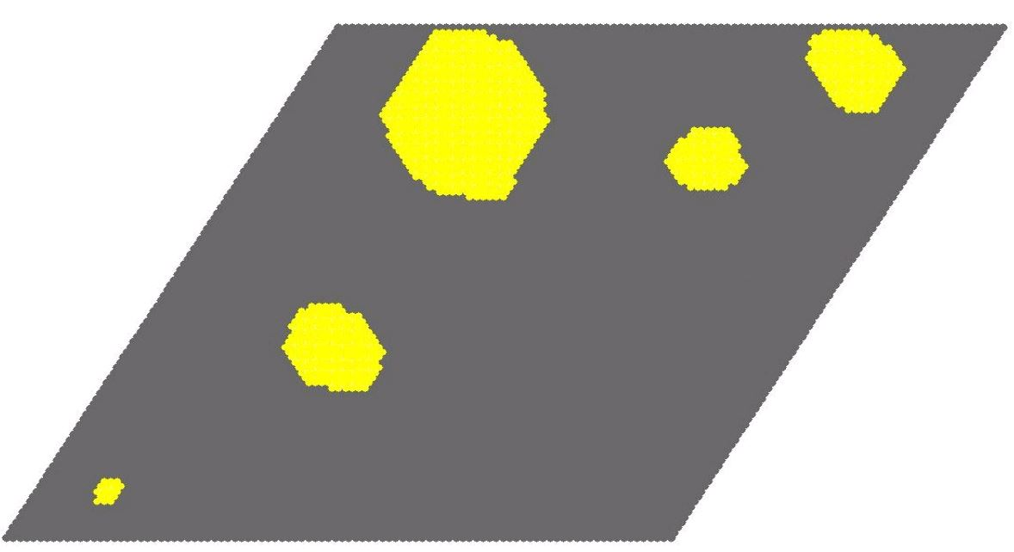

Fig. 3. The simulation result under $E_{B}=1.97eV$, ${ E}_{B}:A=1000$ after 106 steps, the yellow dots are Br atoms.

## The Case with a Small $E_{B}$

According to the information got from a PG student, the values of $E_{B}$ should be about 10-3 eV, which is much smaller than the one set previously. Thus the 0.002 eV bonding energy was taken to be tried in this model.

In this case, it costs more steps to reach the final states with stable Br islands, and some single atom islands always appeared in the whole process, which implies that the bonding energy is too low to hold the atoms.

## Other Values of $E_{B}$

Some other values of $E_{B}$ between the above two were also selected in the simulation. One important result is that with a fixed proportion ${ E}_{B}:A$, the larger the value of $E_{B}$ is, the smaller islands will be formed. The coverage being tried is 10.92%. However, the pair correlation functions in the simulations are not quite similar to the one in the experiment, though the size distribution of the Br islands in simulation can fit the experimental results. By comparing the simulation with each other, the simulation that is most similar to the experiment is the one with EB=0.002, EB:A=5. (Fig. 4, Fig. 5)

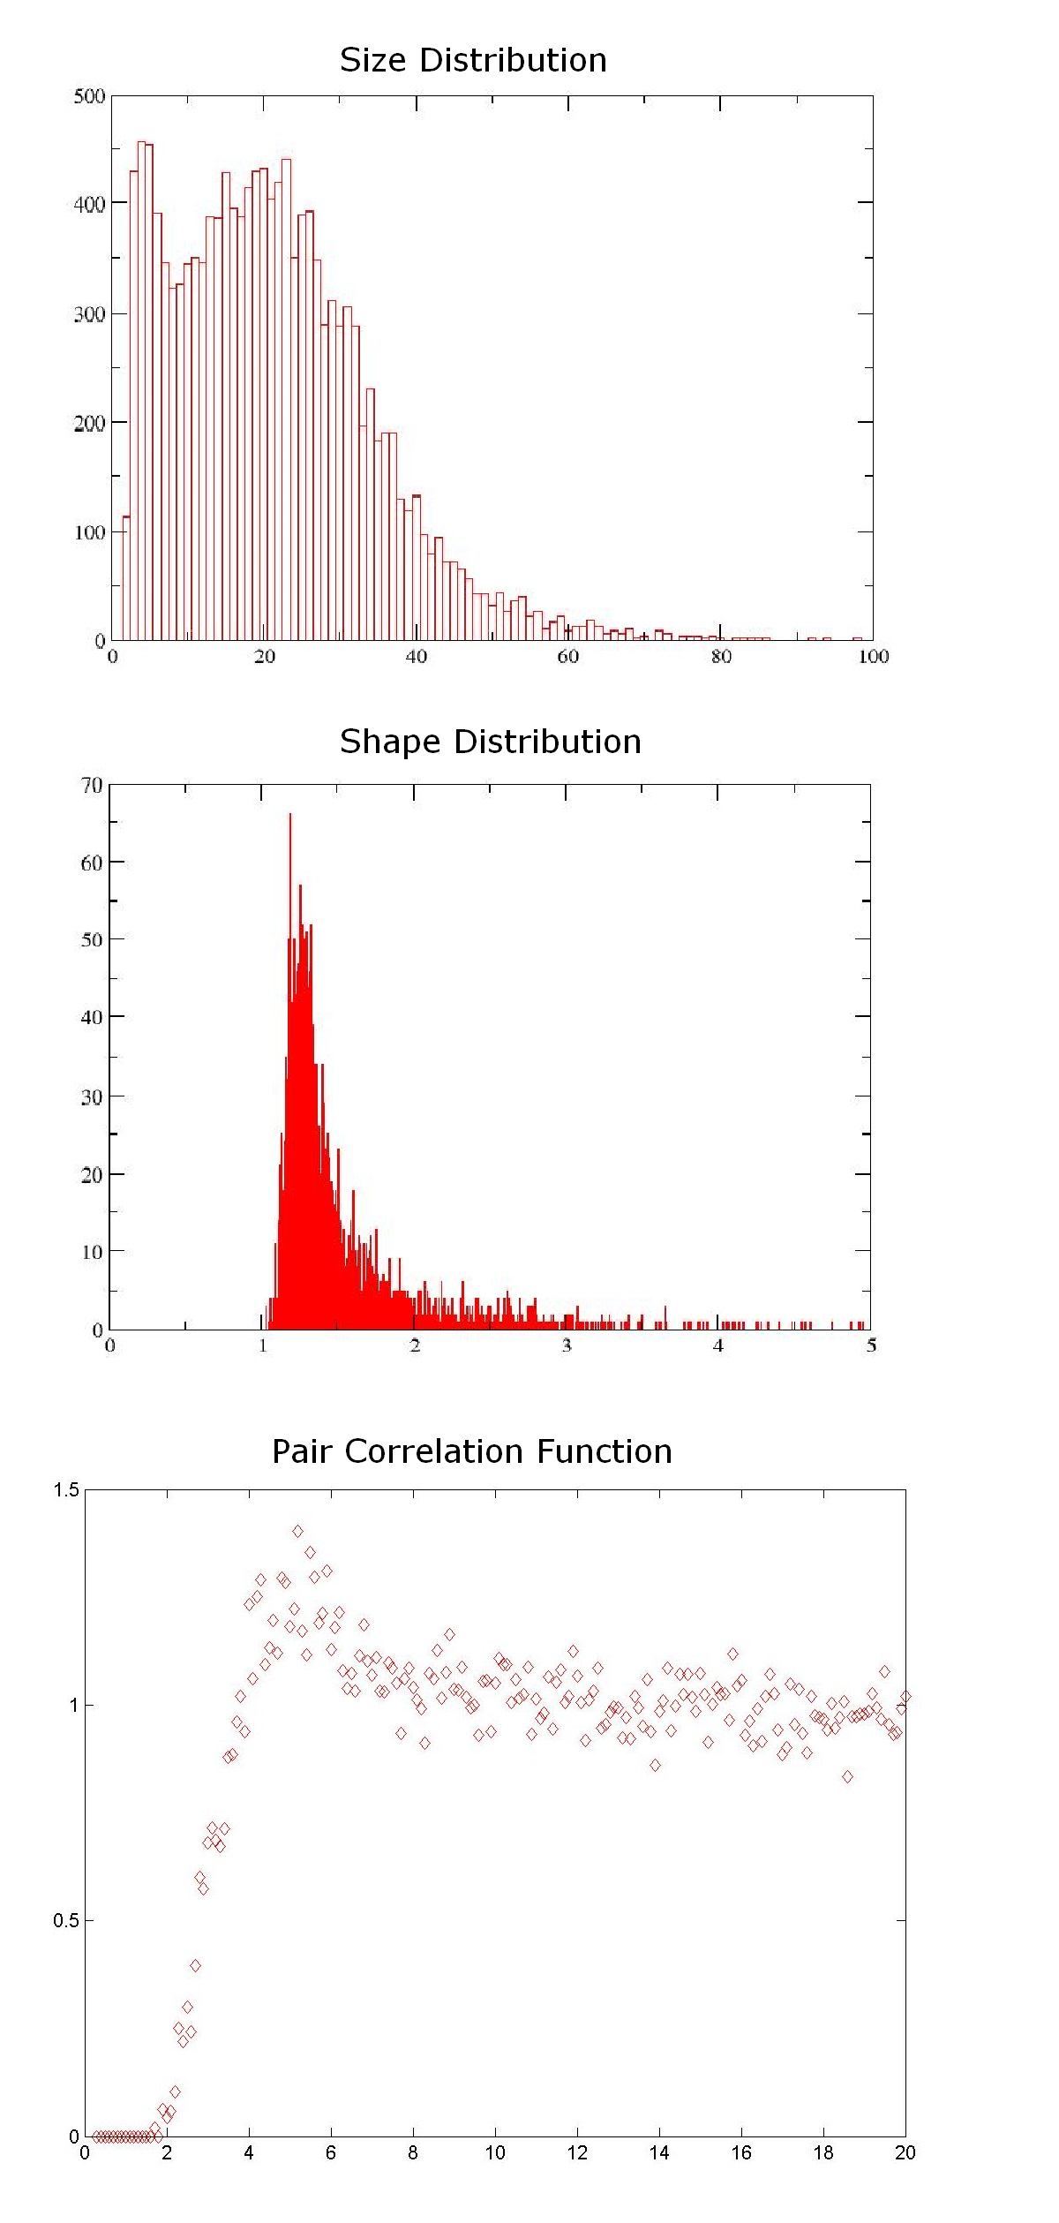

Fig. 4. The experiment data for the case with coverage equals to 10.92%.

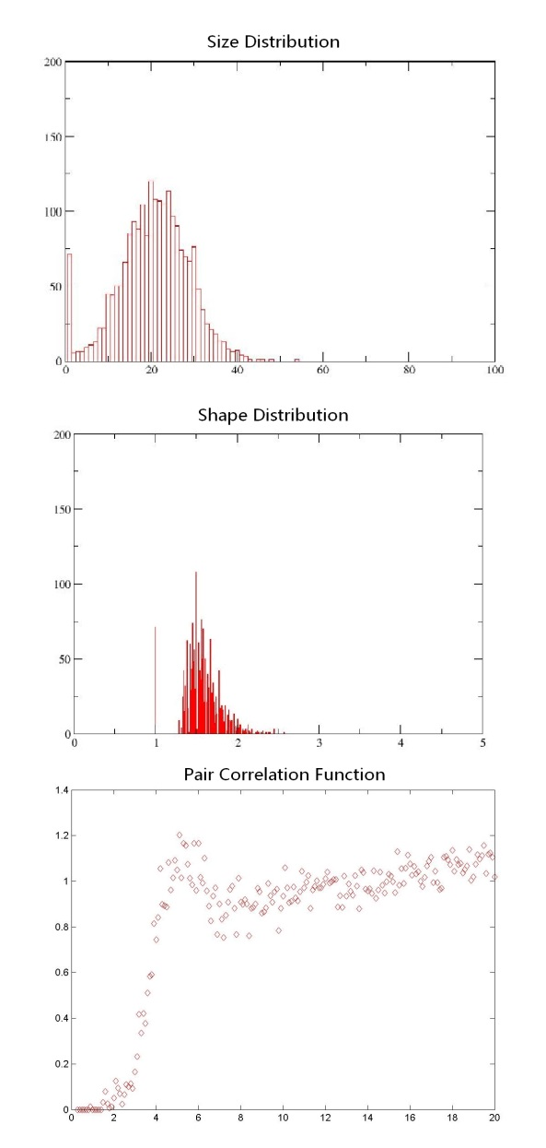

Fig. 5. The simulation result for the case with coverage equals to 10.92%, EB=0.002, EB:A=5,

# conclusion

In this eight-week project, the inconsistence of the simplified model has been verified. As for the original model considering the temperature, the value of EB and the proportion EB:A still remains undetermined since no simulation result is similar to the experiment in all the aspect.

##### Acknowledgment

. I would like to thank Tao Lin and Shiyong Wang for the experiment data, their Matlab program to calculate the coverage, the pair correlation function, and their assistance of programing.

##### References

1. Metropolis, N.; Rosenbluth, A.W.; Rosenbluth, M.N.; Teller, A.H.; Teller, E. (1953). "Equations of State Calculations by Fast Computing Machines". *Journal of Chemical Physics* **21** (6): 1087–1092.

**Appendix**

The programming languages that have been used are C++ and Matlab. The C++ program should be compiled and run under Linux and the host I used is “stu.phys.ust.hk”. Here are programs written for completing the project, and it may cause some time to figure out how to use these programs. Therefore I wrote a brief introduction to these programs:

These two are written for the simplified model. The former one is used for start a new trial of simulation, and the later one is used for continuing the simulation in case the simulation is stopped by some reason. Since the output files are separated txt files, is needed to combine these files. For the case with high coverage, is needed to combine the file while inverse the “color” of atoms and vacant spaces.

 These two are written for the original model which considers the affect temperature. The function of the later is similar to the previous programs.

This program will output the simulation results with a certain interval. By usingto convert the output file to the animation, we could see the process of the simulation.

The program can read the simulation data and count for the size and number of islands. By using the tool “xmgrace” in Linux, one can get the size distribution and shape distribution of the islands.

The program can read the simulation data and convert it into the pictures. Then we can useto analyze these pictures and finally get the pair correlation function of the Br islands.